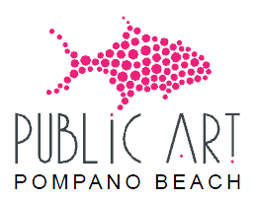
City of Pompano Beach
Public Art Committee

March 21, 2024 5:00 P.M.

MINUTES

- Call to Order - 5:04 P.M.

- Roll Call
Tobi Aycock, Chair Mimi Botscheller, Vice Chair
Donna Schorr Marie Goodrum Johnson
David Miller Mary Lou Hamilton
Karen Moreland Kimberly Harmon, Alternate
Sarahca Peterson, Alternate (Absent)

Others in Attendance
Laura Atria, Public Art Manager
Ty Tabing, Director of Cultural Affairs Department
Michelle Owens, Department Secretary

G. Current Project Updates
4. Powerline Road Entryway Sculpture
The Committee reviewed Innovative Sculpture Design, LLC.’s proposal.

A MOTION was made by Ms. Moreland to approve the proposal selected by the Subcommittee and approve an additional $10,000 towards costs. Motion was seconded by Ms. Miller. Motion passed unanimously.

