155.3505. TRANSPORTATION (T)
A. Purpose |  | Typical Building Type
The Transportation (T) district is established and intended to accommodate the Pompano Air Park and related airport facilities (aircraft operation and maintenance facilities, cargo and freight distribution terminals, transit warehousing), and other complementary or compatible uses—including open area and commercial recreation uses. |  | 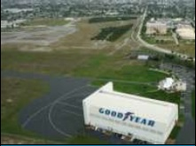  X
B. Use Standards
See Appendix A: Consolidated Use Table, and use-specific standards in Article 4: Use Standards.
C. Intensity and Dimensional Standards ¹
Lot area, minimum (sq ft) | n/a | Typical Lot Pattern
Lot width, minimum (ft) | n/a | 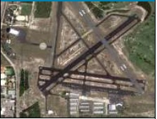  X
Density, maximum (du/ac) | n/a
Lot coverage, maximum (% of lot area) | n/a
Pervious area, minimum (% of lot area) | n/a
Height, maximum (ft) | n/a ²
Front yard setback, minimum (ft) | 25 ³n/a
Street side yard setback, minimum (ft) | 25 ³n/a
Setback from a waterway or canal, minimum (ft) | 15n/a
Interior side yard setback, minimum (ft) | 25 n/a
Rear yard setback, minimum (ft) | 25n/a
Dimensional Standards for Accessory Structures | See Accessory Use -Specific standards in Article 4: Part 3.
NOTES: [sq ft = square feet; ft = feet; du/ac = dwelling units/acre]
1. See measurement rules and allowed exceptions/variations in Article 9: Part 4. No Air Park lease parcels will be created within a minimum of 100 feet from Copans Road, NE 5th Avenue or NE 10th Street. The 100 feet between the edge of right-of-way and the interior lease parcels will be available as a tree planting area for tree mitigation associated with the Airport Operations Area (AOA). Tree locations and species for mitigation will be selected based on compatible heights to avoid creating aviation obstructions and bird/wildlife attractions that are incompatible with aviation operations.
2. Structures within the Air Park Overlay (APO) zoning district must also comply with the height limits in Section 155.3707. Setbacks and height within a lease parcel on the Air Park will be based on horizontal and vertical restrictions related to the existing runway, hangar and aircraft apron/maneuvering areas on a site-specific basis and will be reviewed by the City’s Aviation Consulting Engineer at the Applicant’s expense.
3. 100 ft from N.E. 10th Street right-of-way and N.E. 23rd Street. Landscaping requirements in 155.5203 will not be applied to aircraft aprons. Landscaping in 155.5203 will only be applied within lease parcels in a manner consistent with aviation vertical and horizontal surfaces to ensure no obstructions or wildlife attractions are created and will be reviewed by the City’s Aviation Consulting Engineer for compatibility with aviation design standards at the Applicant’s expense. Existing trees to be removed and mitigated or trees required by 155.5203 that are not appropriate within the Airport Operations Area will be planted prior to CO within the tree mitigation areas along Copans Road, NE 5th Avenue and NE 10th Street.

4. Drainage requirements for each lease parcel must be accommodated on the lease parcel as required by the lease agreement.
Typical Development Configuration
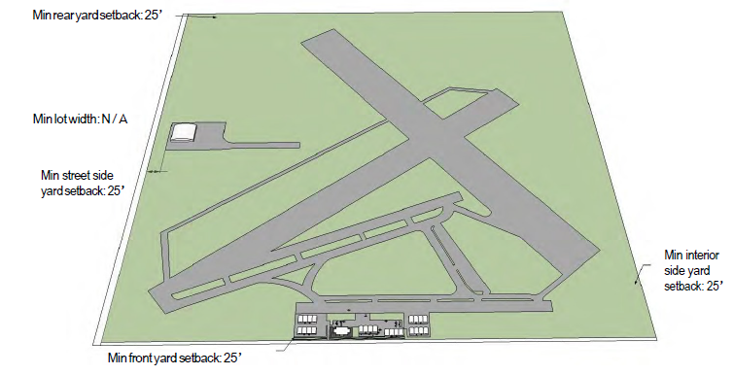
X

